ASSIGNMENT 6 – PART II

1. (5 points)

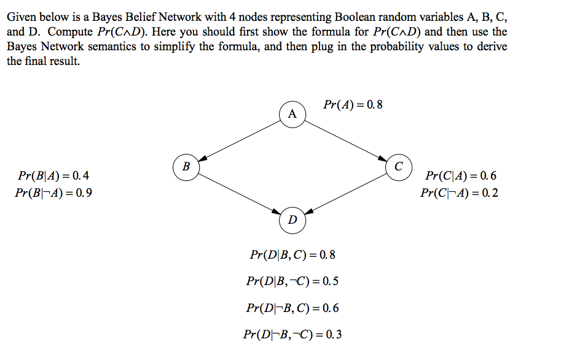

Pr(B) = Pr(B|A) \* Pr(A) + Pr(B|¬A) \* Pr(¬A)

= 0.4\*0.8 + 0.9\*0.1

= 0.32 + 0.09

= 0.41

Pr(¬B) = 1-0.41= 0.59

Pr(C^D) = Pr(D|C) \* Pr(C)

= Pr(D|C) \* [Pr(C|A) \* Pr(A) + Pr(C|¬A) \* Pr(¬A)]

= [Pr(D|C B) \* Pr(B) + Pr(D|C ¬B) \* Pr(¬B)] [Pr(C|A) \* Pr(A) + Pr(C|¬A) \* Pr(¬A)]

= [0.8 x 0.41 + 0.6 x 0.59] [0.6 x 0.8 + 0.2 x 0.2]

= 0.682 x 0.52

= 0.3224



(10 points)

Pr(H|P) = [Pr(P|H) \* Pr(H) ]/ Pr(P)

Pr(P) = Pr(P|H) \* Pr(H) + Pr(P|^H) \* Pr(^H)

= 0.98 \* 0.0005 + 0.03 \* 0.9995

= 0.0304

Pr(H|P) = (0.98\*0.0005)/0.0304

= 0.00049/0.0304

= 0.0161

or 1.61%

3. Given the following Bayes Net (10 points)

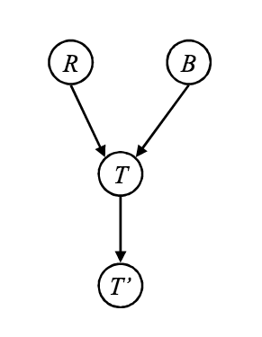

determine and explain whether the following are conditionally independent?

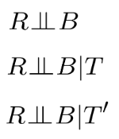

a. In absence of any information, T is a blocking node. Therefore, R and B are CI

b. T is a converging node, and if we have evidence about it or descendants, then it allows flow of information. Thus R and B are not CI

c. b. T is a converging node, and if we have evidence about it or descendants, then it allows flow of information. Thus R and B are not CI

4. Given the Bayes net below, (10 points)

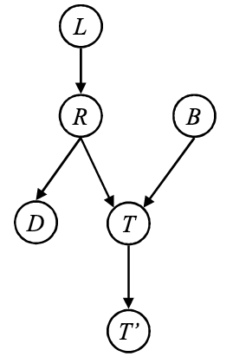

explain whether the following are conditionally independent?

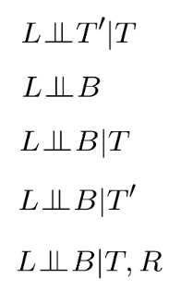

a. T is sequential node in this path. Evidence about it is available => blocking. They are CI

b. T is a convergent node in this path. No evidence about it is available => blocking. They are CI

c. T is a convergent node in this path. Evidence about it is available => not blocking. They are not CI

c. T is a convergent node in this path. Evidence about its descendant is available => not blocking. They are not CI

d. R is a sequential node in this path. Evidence about it is available => blocking node. The nodes are CI.

5 (10 points each = 20 points)

5a. Suppose you have a set consisting on n discrete random variables, which can each take m distinct values. Assuming they are totally independent, indicate how many entries will need to be there in the probability table to specify the full joint distribution for the following:

a. n = 20 and m = 2

b. n = 20 and m = 5

c. n = 500 and m = 10

m^n for all cases.

5 b. Now suppose the n variables form a Bayes net such that the network has one root node, one node with a single parent, two nodes with two parents, and the remaining all have 3 parents each. For the following values on n and m, indicate the total size of the conditional probability table? You can assume that we are storing the full information for each node i.e. for each variable we are storing P(X | Pax) as well as P | Pax).

a. n = 20 and m = 2

b. n = 20 and m = 5

c. n = 500 and m = 10

General idea: for a node with p number of parents, the CPT will have mp+1 entries

For root node, m entries

For single parent node, m2 entries

and so on. Just make sure they add up correctly.

6. Consider the following Bayes net: (10 points)

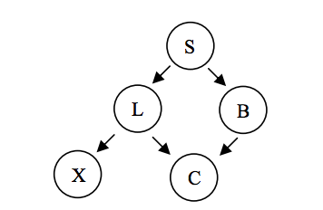

Identify all pairs of nodes that are conditionally independent (CI), when you have following evidence:

a. S i.e. you know value of S, find all pairs that are CI

b. L

c. {L, B}

a. {L, B}, {X, B}

b. {S, X}, {S, C}, {L, B}

c. {S, C}, {S, X}

7. (20 points)



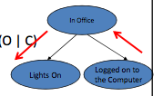

Updated probability of being in office given logged on computer:   
P(O\*) = P(O|C) = P(C|O) \* P(O) / P(C) = 0.8 \* 0.6 / [0.8\*0.6 + 0.4\*0.1] = 0.48/0.52 = 0.923

Now find,   
P(L\*) = P(L|O\*) P(O\*) + P(L| ¬O\*) P(¬O\*) = 0.5\*0.923+ 0.05\*0.077

= 0.465

8. (15 points)

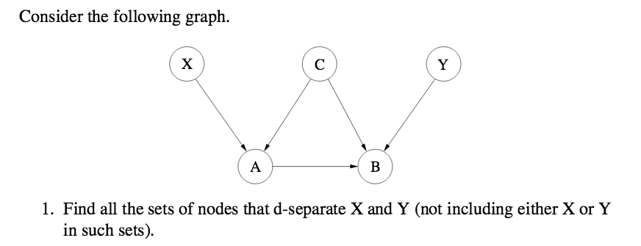

2 paths possible:

1. X → A → B → Y

2. X → A <- C → B <- Y   
(Note: in the first step, while finding paths, don’t look at direction of arrows)

Node A is convergent in 1 path and sequential in another => it’s non-blocking both ways

Node B is convergent in both paths => we do not want evidence about it

Node C is divergent and is only in 1 path

So, B d-separates X and Y if no evidence about it is available.

C can d-separate one path if evidence about it is available